**EXPERIMENT 2**

**AIM:** To perform 16 bit operations ADD,SUBTRACT,MULTIPLY,DIVIDE

**THEORY:** Instructions used in program

|  |  |  |
| --- | --- | --- |
| **Instruction** | | **Description** |
| ADD | Adds data to the accumulator i.e. AL or AX register or memory locations. | | |
| ADC | Adds specified operands and the carry status (i.e. carry of the previous stage). | | |
| SUB | Subtract immediate data from accumulator, memory or register. | | |
| SBB | Subtract immediate data with borrow from accumulator, memory or register. | | |
| MUL | Unsigned 8-bit or 16-bit multiplication. | | |
| IMUL | Signed 8-bit or 16-bit multiplication. | | |
| DIV | Unsigned 8-bit or 16-bit division. | | |
| IDIV | Signed 8-bit or 16-bit division. | | |
| INC | Increment Register or memory by 1. | | |
| DEC | Decrement register or memory by 1. | | |
| DAA | **Decimal Adjust after BCD Addition:** When two BCD numbers are added, the DAA is used after ADD or ADC instruction to get correct answer in BCD. | | |
| DAS | **Decimal Adjust after BCD Subtraction:** When two BCD numbers are added, the DAS is used after SUB or SBB instruction to get correct answer in BCD. | | |
| AAA | **ASCII Adjust for Addition:** When ASCII codes of two decimal digits are added, the AAA is used after addition to get correct answer in unpacked BCD. | | |
| AAD | **Adjust AX Register for Division:** It converts two unpacked BCD digits in AX to the equivalent binary number. This adjustment is done before dividing two unpacked BCD digits in AX by an unpacked BCD byte. | | |
| AAM | **Adjust result of BCD Multiplication:** This instruction is used after the multiplication of two unpacked BCD. | | |
| AAS | **ASCII Adjust for Subtraction:** This instruction is used to get the correct result in unpacked BCD after the subtraction of the ASCII code of a number from ASCII code another number. | | |

PROGRAM AND EXECUTION SCREENSHOT (16 bit):

1.Addition

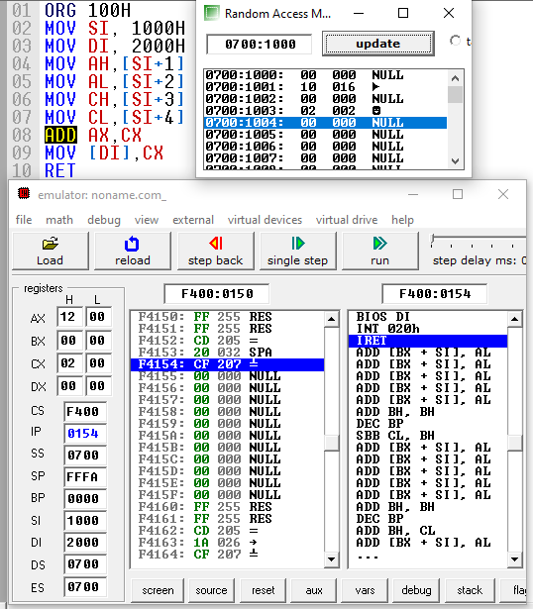

2.Subtraction

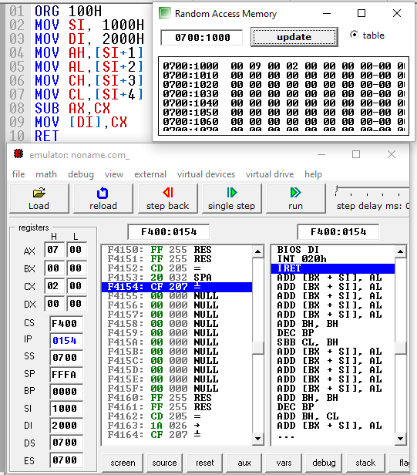

3. Multiplication

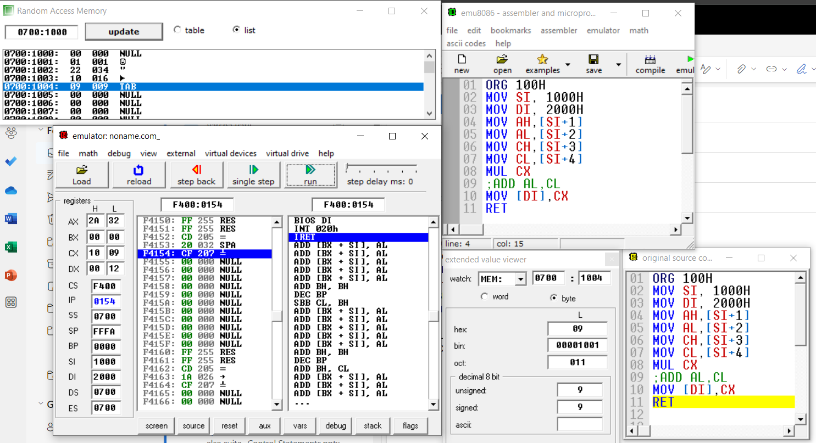

4. Division

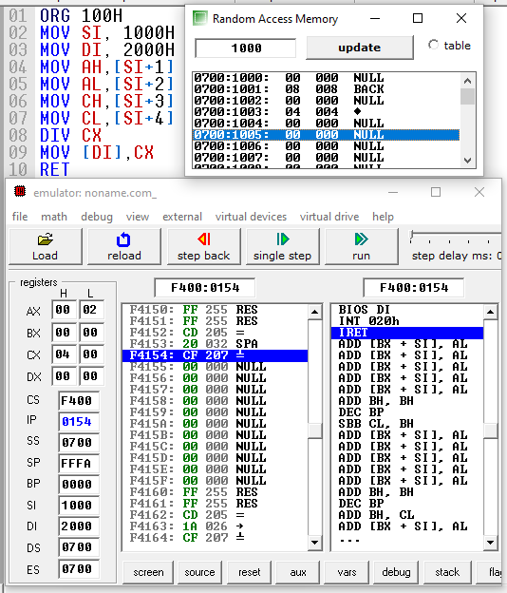

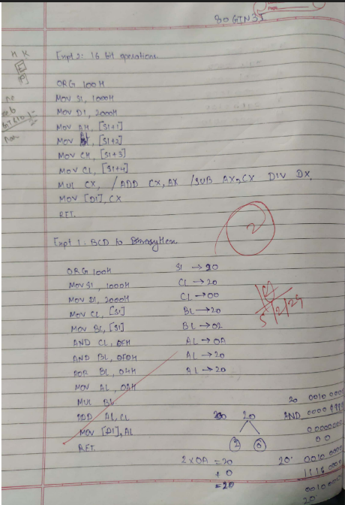

**CONCLUSION**: With the help of Assembly language We have learned to program the code for 16 bit Addition, Subtraction, Multiplication, Division with the help of 16 bit 8086 Microprocessor.